**1.**

**ii.**

**iv.**

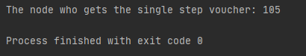

**vi.**

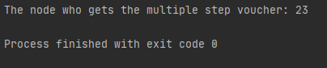

**viii.**

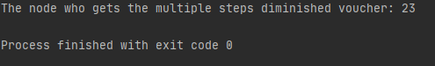

No, there is not difference compare with section **V**.

The number of steps and the rate are not matter, even when we change dramatically the parameters it will be no change.

Because, Closeness centrality calculate the reciprocal of the sum of the length of the [shortest paths](https://en.wikipedia.org/wiki/Shortest_path_problem) between the node and all other nodes in the graph.

**x.**

